

To make money from the expansion of the Chinese market, most oil companies will have to sell much more than gasoline.
Jonathan R. Woetzel
The McKinsey Quarterly, 2002 Number 3

CChina抯 automotive market is predicted to be the third largest in the world by 2008.¹ The accompanying growth in demand for gasoline and related car fuel products梒ombined with government plans to deregulate the sector and the need to address the chronic inefficiency of current distribution梥hould create a juicy opportunity for multinational oil companies as well as for China抯 two domestic giants, PetroChina and Sinopec.
Gasoline reaches the huge Chinese market through a fragmented retail and distribution network of about 90,000 stations, almost all state owned. Many are run more as sinecures than as businesses, often with a staff four to five times larger than the international norm but with less than a quarter of the average gasoline throughput of US stations. The Chinese government, which is well aware of the problem, has resolved not to allow the country抯 energy infrastructure to burden the whole economy: it is fast deregulating the sector, which will be fully opened up to foreign companies in 2004 under the commitments attending the country抯 membership in the World Trade Organization (WTO). Foreign oil companies have hitherto been restricted to one-off local deals in special economic zones or tied to investments in toll-road construction.
Although the stage should thus be set for canny corporations to move into the market, it remains unclear how they will make money. Competition is already driving down retail margins on gasoline, while prices for the best station sites have soared as China抯 large domestic oil companies have rushed to buy them. Oil companies in the West facing similar margin pressures know that most gasoline stations are viable only if they offer general-retail facilities at least as large as a convenience store, in addition to gasoline. This is true in China as well. The highest-volume sites might be made profitable on their fuel revenues alone, but the rest need substantial nonfuel revenues to make a profit.
The strategic implications are clear. In China as elsewhere, the first decision for an oil company is whether to own and operate sites or merely to supply them with gasoline. If the company opts for ownership, it has a choice: to adopt a retail strategy and pursue nonfuel revenues from a portfolio of retail sites or to target only the highest-volume sites, using them to build a high-quality gasoline brand that can also be offered through independent retailers. At present, the Chinese oil majors are pursuing neither strategy; they have simply rushed to grab any available site, where they sell as much petroleum-based product as possible while ignoring the retail potential. The multinationals have been more judicious in selecting sites for their initial joint ventures, but they too have neglected the strategic choice. Unless all of these companies, domestic and international alike, change tack, their investments in expensive Chinese real estate may unravel.
The market and site economics
China抯 dominant oil companies are Sinopec, in the south and east, and PetroChina, which has the more comprehensive refinery and distribution network of the two, in the north and west (Exhibit 1). The two companies aim to capture, between them, 70 percent of China抯 gasoline sales volume by 2005. Since their IPOs, in 2000, they have invested heavily in petroleum-related infrastructure and in brand building. Having already raised their share of sales to more than 40 percent and secured most of the prime sites in the biggest cities, they are on track to meet this target.
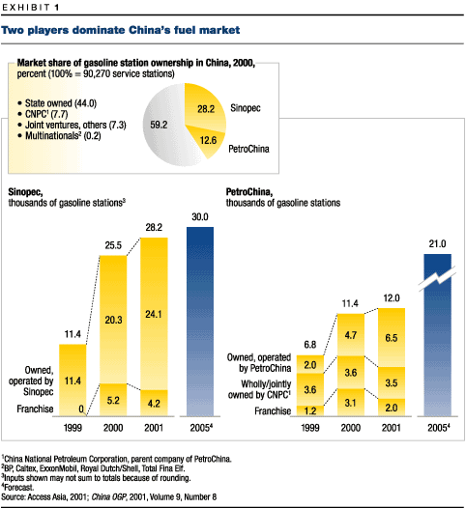
Until 2004, multinational companies will be allowed to own outright only the 300 or so sites they now possess through local deals struck before government deregulation of foreign investment in the sector, in the mid-1990s, but they can build up their holdings through joint ventures with Chinese companies. BP, ExxonMobil, and Royal Dutch/Shell are establishing joint ventures with PetroChina and Sinopec by contributing capital for the purchase of sites and by supplying higher-margin premium fuels; BP and PetroChina, for example, aim to boost their holdings to 950 stations by acquiring 670 stations from local companies in Fujian and Guangdong. Such joint ventures bind the partners only in specific provinces and have so far been formed in just 4 out of 27 of them. For the remainder, the options of both parties are still open.
The 60 percent of sales not controlled by the two Chinese leaders is currently held by various quasi-governmental entities, including local and provincial authorities and state-owned enterprises. City governments, for example, have started their own retailing groups, often built around local highway-construction projects. Some private operators are also emerging: for example, China Resources Enterprise, a holding company based in Hong Kong, has 23 stations and is thinking about opening more. But in general, smaller companies, daunted by the bidding power of PetroChina and Sinopec, are holding back.
Both of the majors hope that their spending will create a profitable structure for China抯 gasoline-retailing industry after the market opens up in 2004. International experience shows that gasoline retailing tends to be relatively profitable wherever the top three participants control 80 percent of the market, growth is strong, and the supply of gasoline is short. China should meet these conditions. PetroChina and Sinopec are consolidating the market by buying out their independent rivals and, given their head start over the multinationals, should succeed in gaining a leading position in the market. Growth in demand is forecast to remain high, especially for high-quality gasoline. And although supply is currently in balance with demand at the national level, it runs short in the coastal regions, where both demand and growth are greatest.
Retail margins are tightening fast, however. As in almost every deregulated Chinese industry, domestic price competition will probably be severe as the market opens up. PetroChina and Sinopec fought several damaging price wars from 1997 until they were restrained in 1999 by state-imposed price controls that are now being removed in tandem with China抯 entry into the WTO. The resumed price competition will intensify when new foreign and domestic companies are permitted to purchase sites in 2004. Moreover, all companies in the market will gain greater access to gasoline as import tariffs for refined products fall to 5 percent, from 9. Where comparable reforms have taken place梚n Australia, France, Israel, Japan, and New Zealand梤etail margins have dropped by up to half.
In anticipation of this fiercely competitive future environment, PetroChina, Sinopec, and new entrants willing to take them on are ratcheting up spending on locations, brands, and marketing. Good locations梩he 20 percent of urban gasoline stations that generate 60 percent of the revenues梐re scarce, and zoning regulations and the high cost of land limit new entrants. These prime sites, which move more than 1,500 tons in volume and generate over 900,000 renminbi ($108,700) in fuel-related gross margins a year, currently sell for up to 20,000,000 renminbi, three to six times the price of a station with equivalent turnover in the United States or Europe. The inflated costs at the high end of the market are also dragging up the price of smaller stations, to 5,000,000 to 10,000,000 renminbi. The cost of promotional campaigns, including television advertising, is about as steep as it is in developed markets.
Making sites pay
Selling gasoline and diesel fuel through retail outlets is a costly (and therefore risky) business. Unless PetroChina, Sinopec, and the foreign joint venture partners of both companies reconsider their indiscriminate buying of sites, they could find that their station portfolios hold more balance sheet liabilities than assets.
It is vital to make the sites pay, but how? There is little scope to cut operating costs, which are already low by global standards; labor, for example, is relatively cheap if inefficient. Capital costs are largely fixed once a station has been bought. Wholesale margins, on which the Chinese majors have usually relied to subsidize their retail outlets, will probably dwindle to the cost of transport and storage as WTO commitments and other reforms take effect. The truth is that the economics of most sites won抰 work unless there are significant nonfuel sales, for they improve site margins by lifting revenues without raising costs in a comparable way (Exhibit 2). Petroleum companies thus have three possibilities: they can focus on the retail opportunity of their sites, concentrate on a high-quality fuel service through the highest-volume sites, or ignore retail altogether and be wholesalers of commodity fuels.
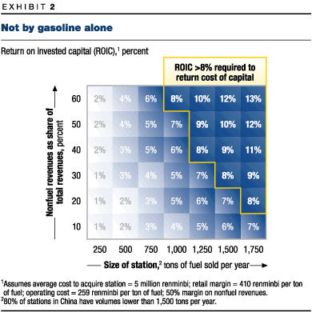
The retail strategy
Elsewhere in the world, multinational oil companies have compensated for tight margins on gasoline by investing in additional revenue streams. This kind of strategic behavior takes place in the context of a global retail sector moving from ownership of product categories to ownership of retail "occasions"梩he way-to-work or weekend stop for gasoline and incidentals, routine Saturday shopping, the less frequent household stock-up. Gasoline stations are designed to attract customers who want more than just fuel for their cars, and in Europe and the United States these formats now generate as much revenue from extras as from gasoline.
In developed economies, this model has been adopted slowly because it takes time to convert or dismantle the legacy assets of a long-established gasoline-only strategy. Chinese players have an opportunity to go straight from the basic gasoline model to integrated retailing. Yet so far, PetroChina, Sinopec, and even the multinationals have been reluctant to pursue nonfuel retail strategies on their current sites, for they have been persuaded that, in China, the ubiquity of local mom-and-pop stores means that convenience stores at gasoline stations are redundant and that margins on nonfuel items are too thin. The marketing efforts of these companies have thus been confined to gasoline, and their sites offer no more than a limited selection of low-cost additional goods and services such as cigarettes, snacks, and auto lubricants.
Nonetheless, the integrated retail model for gasoline stations can succeed in China. As working hours and prosperity increase, the Chinese are more and more willing to pay for convenience and brands. Car drivers, who are generally among the most affluent people in the country, are beginning to demand offerings not available at mom-and-pop stores, such as foreign brands and technology-based services. And the economics should work, since even small nonfuel items often have profit margins of more than 50 percent. Owning a network of sites further improves margins for individual locations by delivering scale benefits for overhead costs such as marketing and administration as well as purchasing scale for both fuel and nonfuel items.
The key is to start with an attractive retail site梡erhaps incorporated into an entertainment or commercial development that could also draw pedestrians梐s opposed to a pure gasoline stop. Chinese consumers are already familiar with retailing concepts such as hypermarket chains, specialty stores, and greatly improved supermarkets and department stores, which have all emerged over the past 10 to 15 years. Most of these formats have been successful, though convenience stores have fallen prey to oversupply and margin pressures.² Given this rather mixed experience, profitability will depend on three factors.
The first is early entry into the market. Only companies that have been quick to introduce innovative formats and to gain national scale have made their retail ventures pay. Carrefour led the pack with hypermarkets, thereby securing a leading market share and leaving local and foreign competitors with less attractive locations. Yet the need to build scale quickly shouldn抰 persuade companies to overpay; instead they should look for opportunities in midsize cities, which represent up to 40 percent of national demand for gasoline and where retail demand is now growing fastest. Here there is still a chance to enter the market early and to establish a strong brand presence without overpaying for sites.
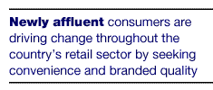
Developing the right retail proposition is the second factor. China抯 newly affluent consumers are driving change throughout the country抯 retail sector by seeking convenience and branded quality. For a retail gambit to work, gasoline stations must appeal to prosperous consumers, such as people who drive their own private cars (accounting for upward of 40 percent of new-car purchases in 2000), as well as the young motorcycle riders, who still dominate station forecourts and are more likely to try out new and foreign brands. To appeal to these categories of consumers, gasoline retailers will need to offer not only high-quality goods梥uch as prepared and packaged foods, including a substantial number of foreign brands梑ut also services such as DVD rentals, photographic processing, a pick-up location for Internet orders, laundry, mail, and pharmacy counters. The precise mix and the design of the site will depend on the market segment the retailer aims to serve: affluent but more traditional car drivers or younger motorbike riders. But retailers must also bear in mind the needs of taxi drivers, who still account for most gasoline consumption in China and look mainly for high-quality gasoline and good service.
The third ingredient is the development of retail skills beyond the usual level of basic expertise. Managing a network of retail sites involves the continual development of a portfolio of options from which each site can draw梐n undertaking that requires skills in concept design, partnering, and venture capital. The state-owned Chinese oil companies will need to develop these skills both organically and through joint ventures.
The gasoline specialist strategy
Given the high cost of owning a large network of retail sites, and the accompanying pitfalls, oil companies might decide instead to become gasoline specialists. Pursuing this strategy would involve buying only those high-volume sites that have sufficient sales of gasoline and auto-related services to make a profit. Elsewhere, the company抯 branded gasoline products would be sold through a network of retail partners.
The rationale of the gasoline specialist route is that auto fuel is a technically differentiated product and that branded, quality products can command a premium. China, with its shortages in domestic supply and its increasingly discerning consumers, is thus promising ground for the gasoline specialist. In the case of auto lubricants, for example, the quality segment of the market accounts for only 7 percent of the volume but for more than 30 percent of the value; margins are up to three times those for the commodity lubes sold by local suppliers. The push to quality is already being promoted by government crackdowns on fake and counterfeit products and by WTO-inspired moves to encourage the use of high-quality gasoline with cleaner emissions. Since China抯 refineries operate far below international benchmarks and domestically generated high-quality gasoline is scarce,³ multinational companies have a clear opportunity. About 20 percent of all gasoline sold in Guangdong, for instance, is imported, and industry forecasts suggest that this amount will rise slowly over the medium term.
For multinationals not bound by joint ventures with the leading Chinese contenders, the gasoline specialization strategy makes particular sense, for foreign companies have access to good gasoline and a reputation for product quality and brand strength. A typical foreign-owned gasoline station in China sells as much as two times more premium gasoline than do locally owned stations, and its prices can be 5 to 10 percent higher than theirs even on basic products (Exhibit 3). Multinationals that haven抰 spent heavily to acquire large numbers of low-volume stations can cherry-pick the best of the new sites and then focus on supplying high-quality gasoline to any independent retailers that emerge.
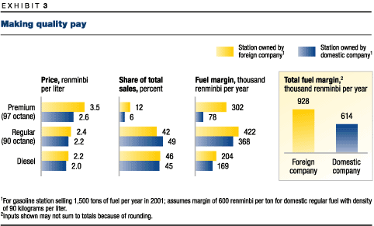
The gasoline specialization strategy relies on three key elements. First, such a specialist should buy only high-traffic sites and perhaps divest sites with smaller volumes. Sites that sell more than 1,250 tons a year are not just the only ones that make a profit without significant nonfuel sales but also can create local brand preferences. Second, the specialist will need strong retail partners梖oreign and local梩o get the necessary scale for its products. Carrefour and Wal-Mart, which are building networks of retail sites in China, are obvious partners, but Jet, QuikTrip, Tesco, and even McDonald抯 might also be suitable. Moreover, since the structure of China抯 retail sector is strongly regional in character, multinationals will need to build relationships with a number of local retail partners. Finally, a gasoline specialist should differentiate itself on products and services, not price. In addition to high-quality gasoline, it must offer quick and friendly assistance, convenient layouts, links to company- or card-payment schemes, and services such as repairs and car washes. To reinforce the message that quality is paramount, prices shouldn抰 be visible from the street.
Can China抯 oil companies realistically pursue the gasoline specialization strategy? There are certainly problems. Although these companies may decide to scale down their investment in retail sites, the quality of their gasoline and service is still relatively poor, and their brands, though well-known, are perceived as being of lower quality than those of the multinationals.⁴
Sticking to wholesale
Local and Asia-Pacific producers and merchant refiners, such as the Chinese National Offshore Oil Corporation, that can抰 invest in a substantial retail position could steer clear of retailing altogether and focus on supplying independent retailers. Once the industry has consolidated, the remaining ones will be looking for a secure source of local gasoline under their own or franchised brands. For Chinese companies that have already invested heavily in their own sites, this path might not be an acceptable choice. But for many regional refiners梐t least if the costs of distribution aren抰 prohibitive梚t could prove a safe way to operate as competition intensifies.

Chinese and multinational oil companies, building on their established supply positions and brands, are investing heavily to sell gasoline in the fast-growing Chinese market. But with falling margins, aggressive competition, and ever more demanding consumers, selling gasoline in China isn抰 a simple game. The size of the country, the abundance of distinct regional markets, and the number of independent sites still available give all interested parties the ability to map out profitable strategies. But unless these companies get it right梐nd to do so, many of them will have to realize the full potential of retail operations梩he black gold of a billion consumers may become just another drop in the sea of Chinese red ink
Notes:
Jonathan Woetzel is a director in McKinsey抯 Shanghai office.
The author wishes to thank Carlo Wai-Keung Yu for his contributions to this article.
¹See Paul Gao, "A tune-up for China抯 auto industry," The McKinsey Quarterly, 2002 Number 1, pp. 144?5. Only the United States and Japan will have larger markets for gasoline. China抯 market for it is growing by 4 percent a year, about double the rate of the developed world.
²Convenience stores accounted for almost 2.5 percent of retail sales in 2001, and local and international chains plan to expand further. Yet Shanghai and some other cities already have five times more convenience stores per unit of GDP than Hong Kong; it has taken nine years for 7-Eleven to break even in Guangdong, where it has 72 stores; and Lawson抯桱apan抯 largest convenience store operator梙as 87 stores in Shanghai but is still in the red after six years.
³In China抯 downstream sector, the legacy of supply-driven planning is average utilization of less than 70 percent; high-cost, low-scale refineries; and extensive transport bottlenecks. PetroChina抯 downstream sector lost more than $1 billion in 2000, while Sinopec has consistently missed its operating targets. In most cases, investing to improve refineries is impossible given their location, scale, and sources of crude oil. Gradual shutdowns are unavoidable.
⁴China抯 oil companies are trying to make the quality of their products, channels, and marketing more consistent by building, for example, high-quality lubricant brands such as Great Wall (Sinopec) and Seven Star (PetroChina)

